AWS SQS, Amazon MQ Task

Overall Task Title
Implementation and Validation of Messaging Services Using AWS SQS and Amazon MQ
Overall Task Objective
To design and implement reliable messaging solutions on AWS using Amazon SQS and Amazon MQ (RabbitMQ). This task demonstrates how to create, configure, and validate both fully managed queue-based messaging and broker-based messaging services to enable decoupled, scalable, and fault-tolerant communication between distributed application components.
Overall Task Prerequisites
- Active AWS account with permissions for Amazon SQS, Amazon MQ, IAM, VPC, and CloudWatch.
- AWS region selected (us-east-1).
- Basic understanding of messaging concepts such as queues, producers, consumers, and message brokers.
- Web browser access to AWS Management Console and RabbitMQ management console.
- Credentials configured for RabbitMQ broker access.

Task Title
Create and Validate an Amazon SQS Standard Queue with Message Send and Receive Operations
Objective
To create an Amazon SQS Standard queue with encryption enabled, configure basic access policies, and validate queue functionality by sending, receiving, and deleting messages. This task demonstrates how Amazon SQS enables reliable, decoupled message communication between distributed application components.
Prerequisites
- Active AWS account with access to Amazon SQS and CloudWatch.
- Required IAM permissions to create and manage SQS queues.
- Web browser access to the AWS Management Console.
- AWS region selected (us-east-1).
Steps Performed (Amazon SQS)
- Opened AWS Management Console.
- Navigated to Amazon SQS service.
- Viewed the Amazon SQS overview page.
- Clicked on Create queue.
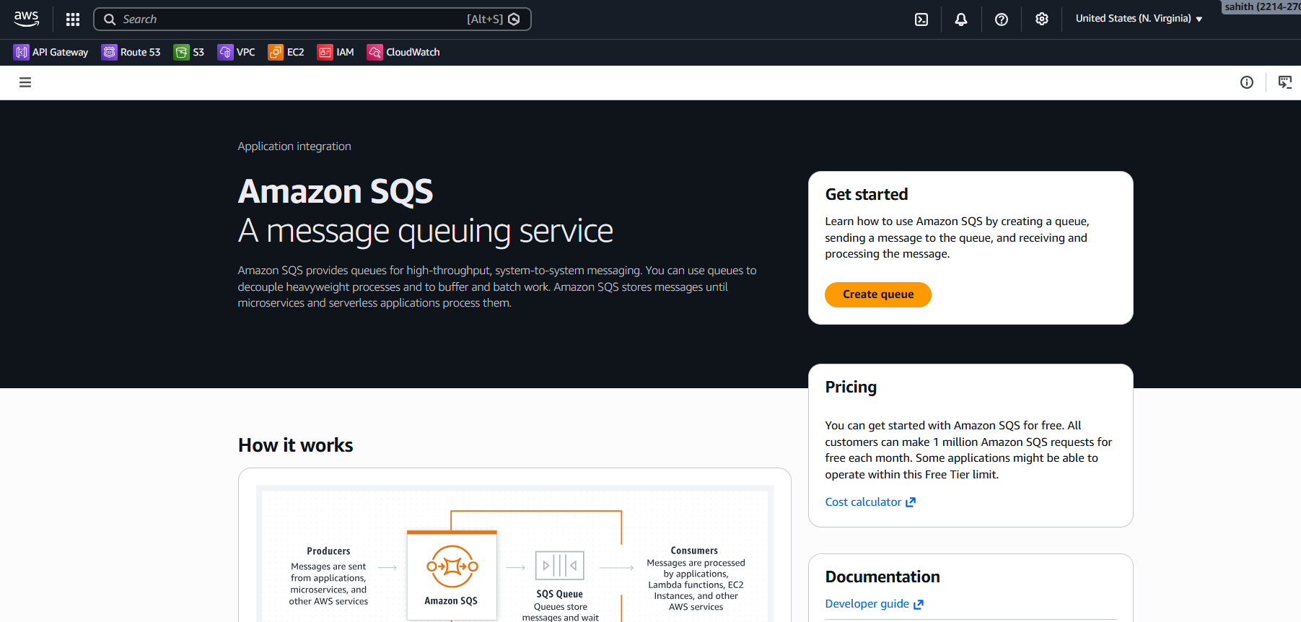
- Selected Standard queue type.
- Entered the queue name as tasksqs.
- Kept default settings for:
- Visibility timeout (30 seconds)
- Message retention period (4 days)
- Enabled Server-side encryption.
- Selected Amazon SQS key (SSE-SQS) for encryption.
- Configured Access policy using Basic method.
- Allowed only the queue owner to send messages.
- Allowed only the queue owner to receive messages.
- Kept Redrive allow policy disabled.
- Kept Dead-letter queue disabled.
- Skipped adding tags.
- Clicked Create queue.
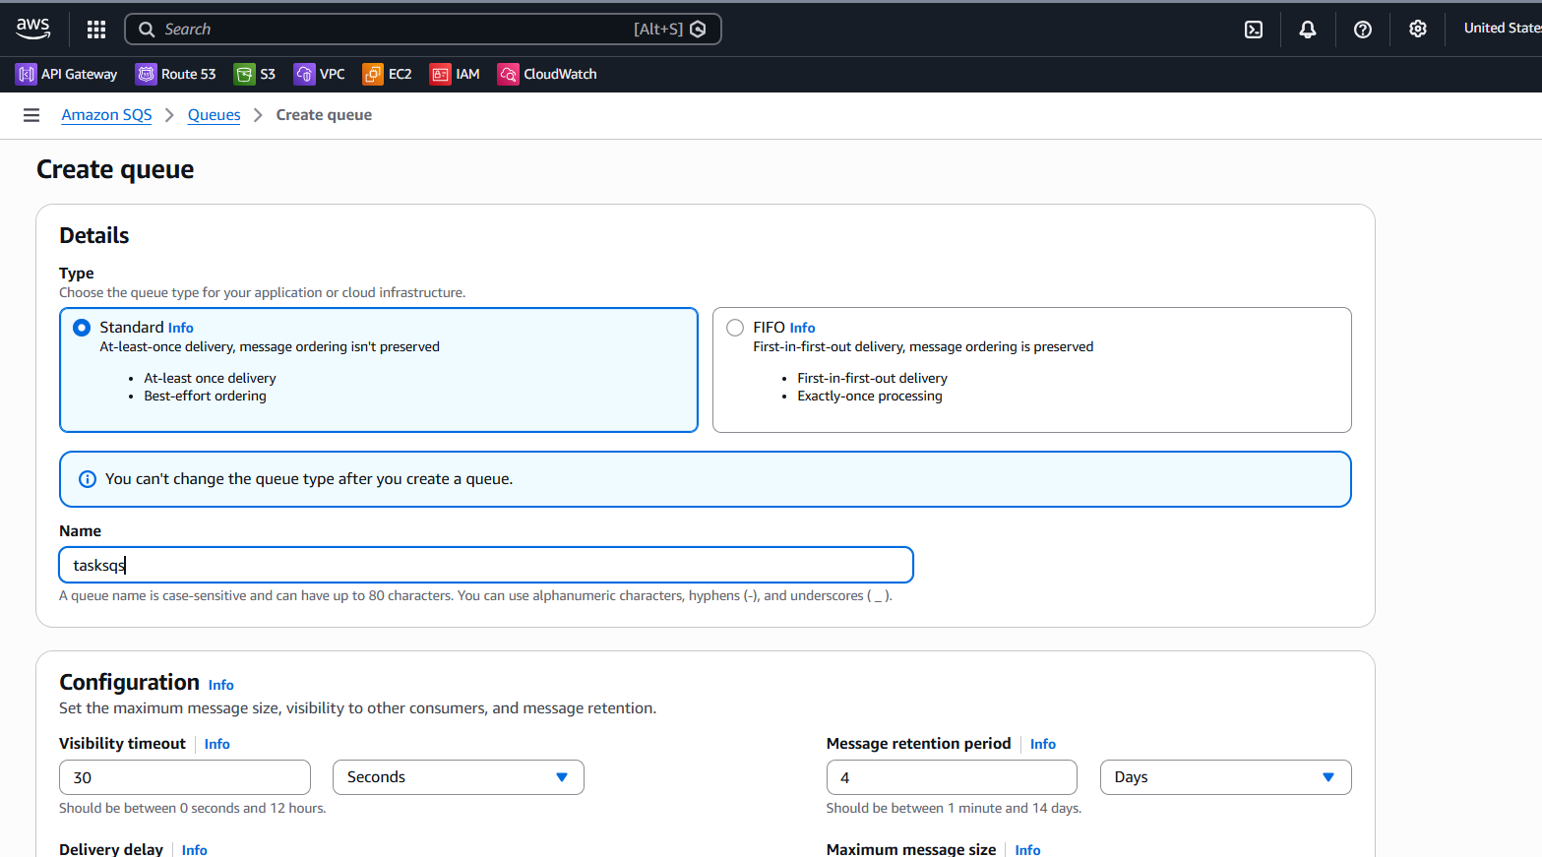

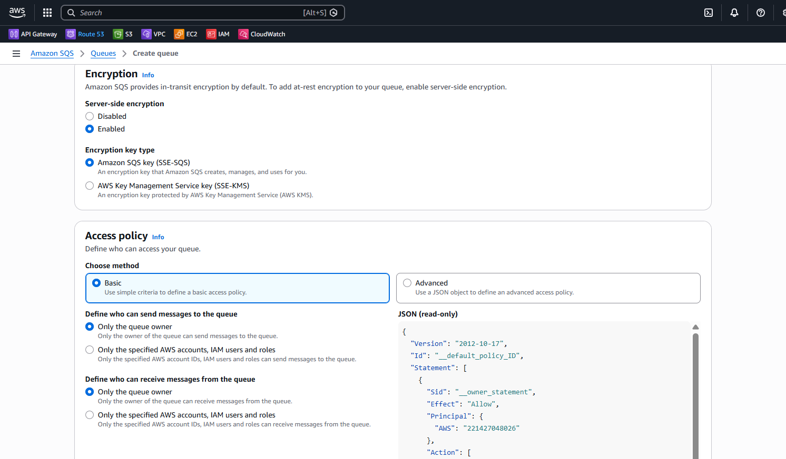
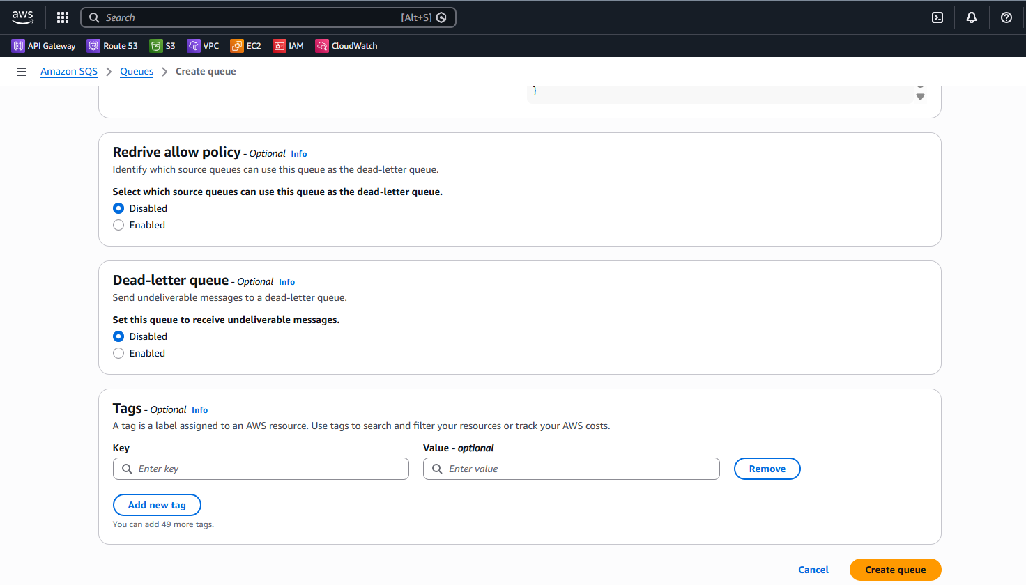
- Verified that the queue tasksqs was created successfully.
- Viewed queue details including:
- Queue type: Standard
- Encryption: SSE-SQS
- Queue URL and ARN
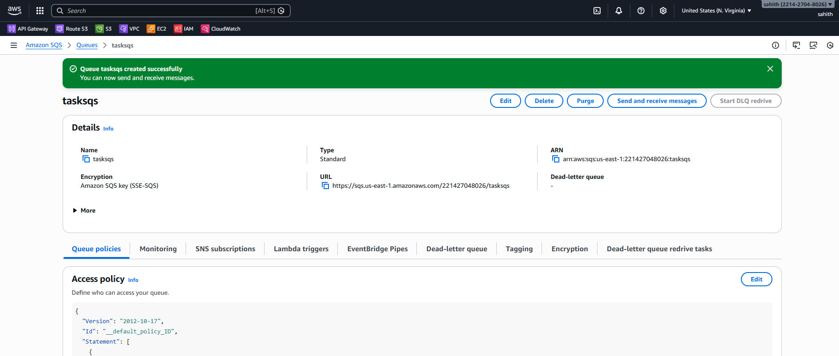
- Opened Send and receive messages for the queue.
- Entered a message body: “Hi this is sahith”.
- Clicked Send message.
- Confirmed the message was sent successfully.
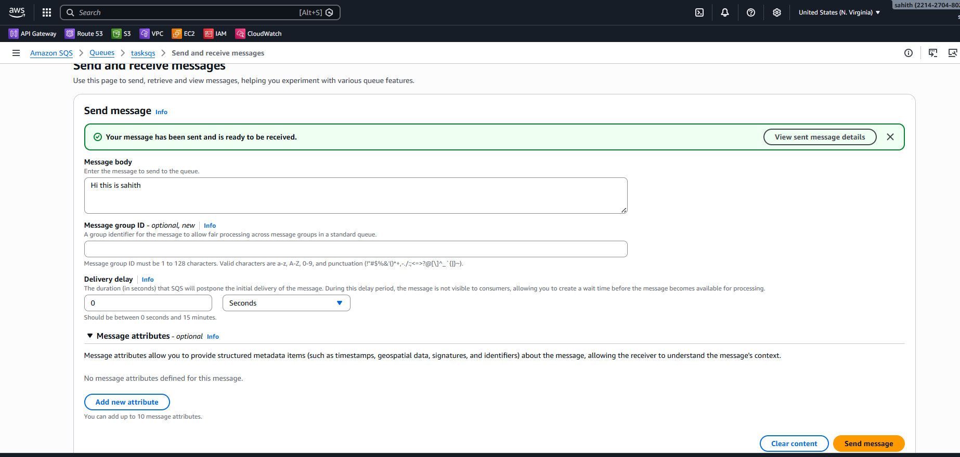
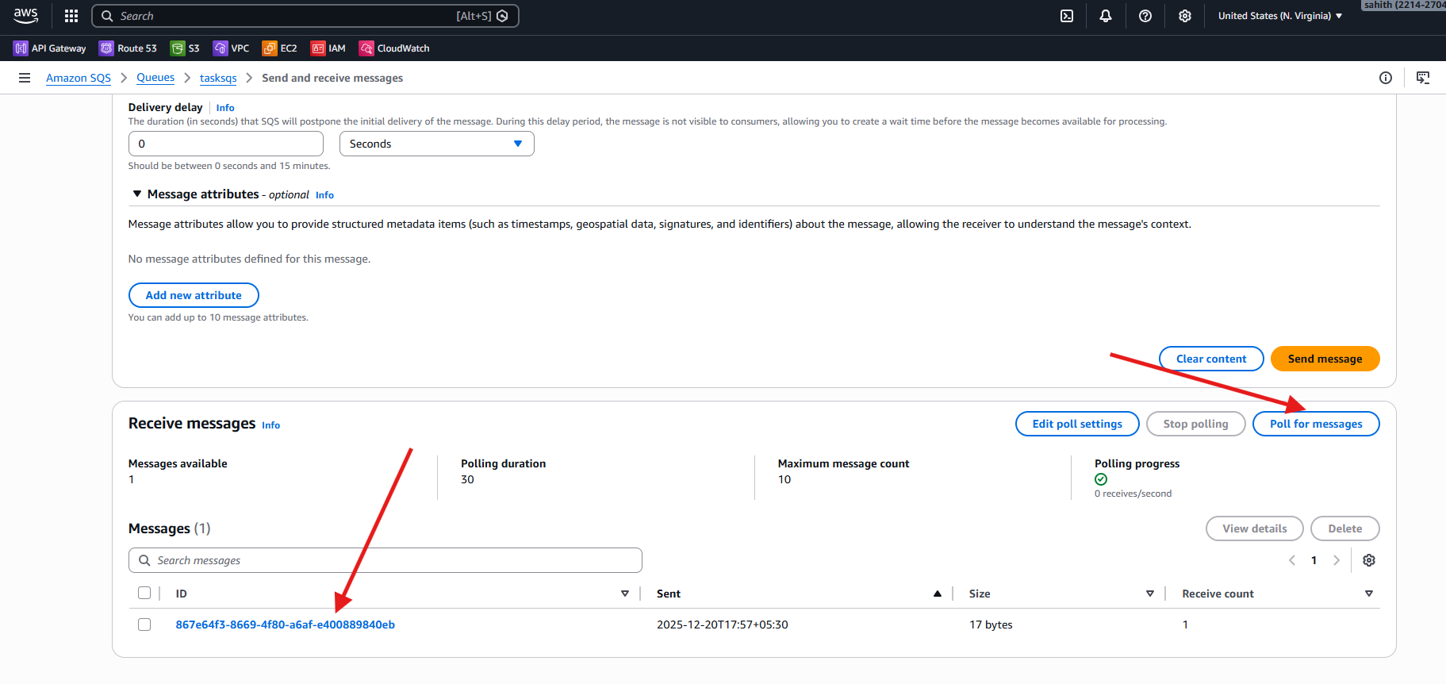
- Clicked Poll for messages.
- Received one message from the queue.
- Opened the received message to view message details.
- Verified the message body content.
- Clicked Done after reviewing the message.
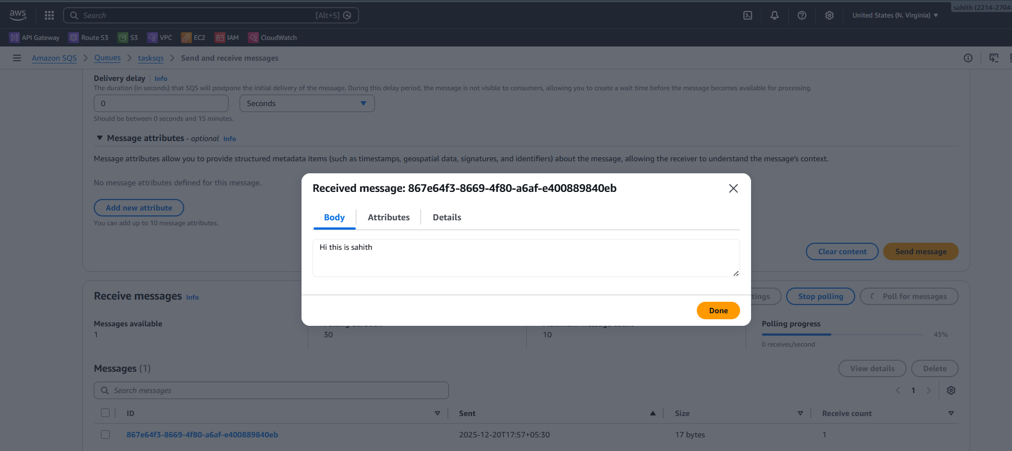
- Deleted the received message from the queue.
- Confirmed that the message was deleted successfully.
- Verified that no messages were available in the queue.
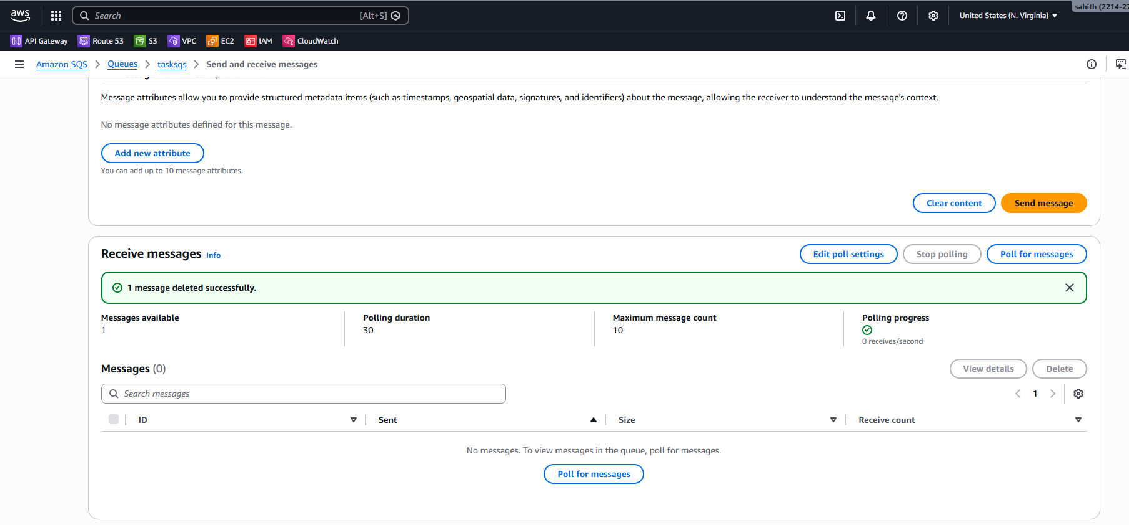
- Opened the Monitoring tab for the SQS queue.
- Viewed CloudWatch metrics including:
- Number of messages sent
- Number of messages received
- Number of messages deleted
- Number of empty receives
- Approximate number of visible messages
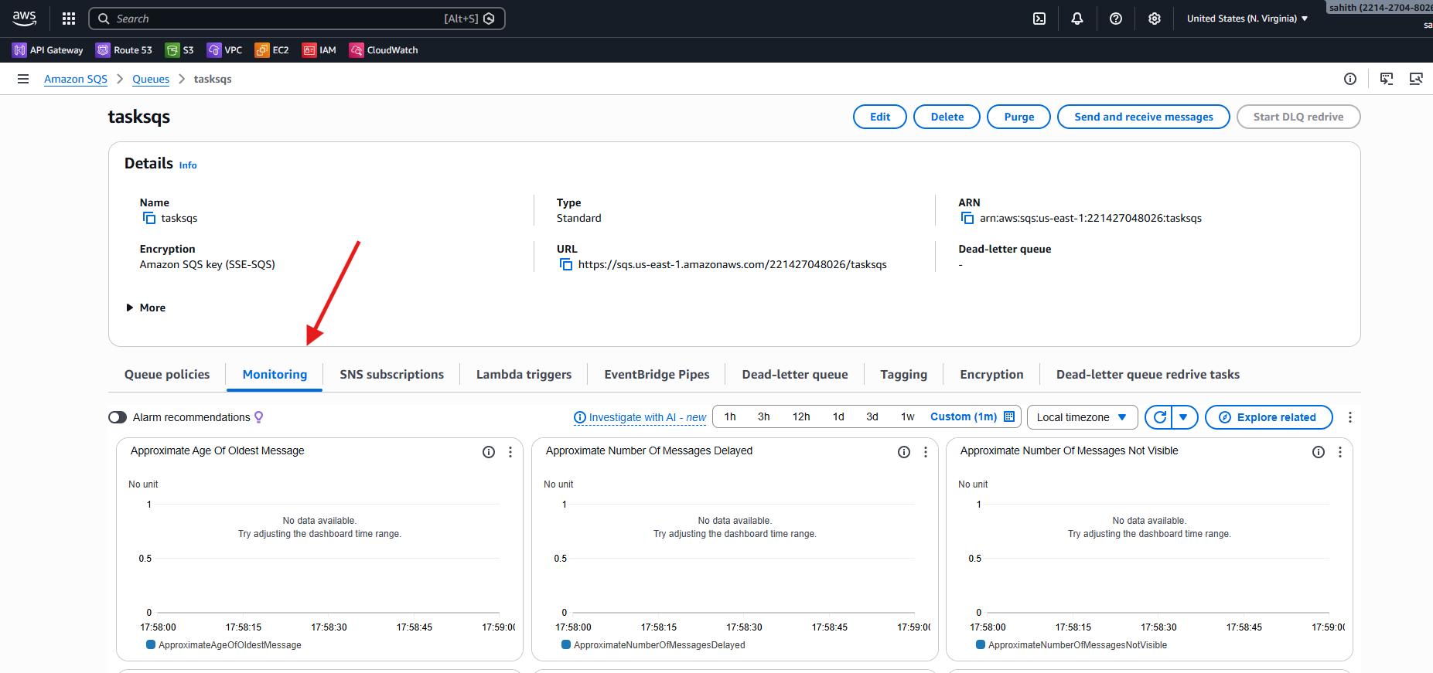
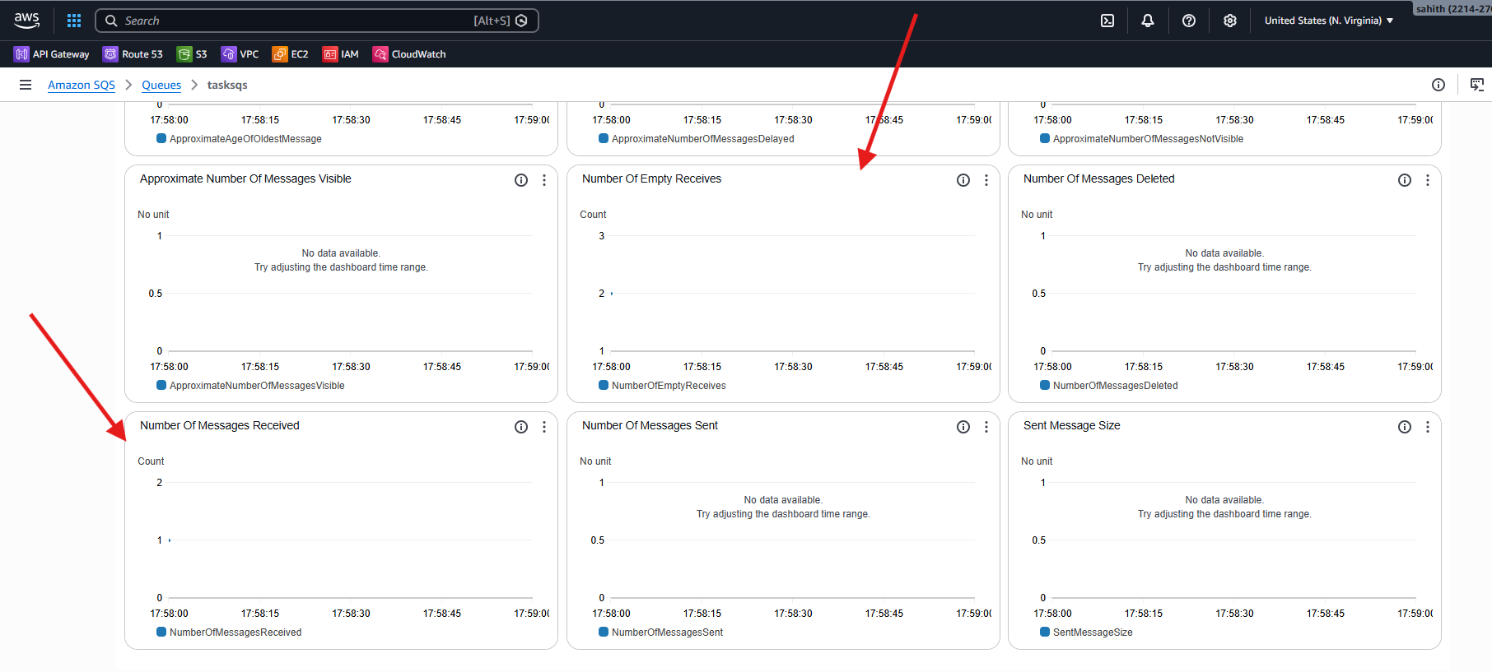
Validation steps:
- Queue tasksqs is created successfully with Standard type.
- Server-side encryption (SSE-SQS) is enabled for the queue.
- A message is successfully sent to the queue.
- The message is received and its content is verified.
- The message is deleted successfully from the queue.
- CloudWatch monitoring metrics reflect:
  - Messages sent
  - Messages received
  - Messages deleted
  - Empty receives
Conclusion:
Amazon SQS was successfully configured and validated by creating a Standard queue with encryption and basic access policies. Message send, receive, and delete operations worked as expected, and monitoring metrics confirmed correct message flow. This task demonstrates the effective use of Amazon SQS for asynchronous, reliable communication in cloud-based architectures.

Amazon MQ

Task Title
Create and Access an Amazon MQ RabbitMQ Broker Using the Web Management Console
Objective
To deploy an Amazon MQ RabbitMQ broker, configure broker access credentials, and validate successful broker operation by accessing the RabbitMQ web management console. This task demonstrates how to provision a managed message broker and verify its availability and functionality through the RabbitMQ UI.
Prerequisites
- Active AWS account with permissions for Amazon MQ, VPC, and IAM.
- AWS region selected (us-east-1).
- Basic understanding of message brokers and RabbitMQ concepts.
- Web browser to access the RabbitMQ management console.
- Broker credentials (username and password) configured during broker creation.
Steps Performed (Amazon MQ – RabbitMQ)
- Opened AWS Management Console.
- Navigated to Amazon MQ service.
- Viewed the Amazon MQ overview page.
- Clicked on Create brokers / Get started.
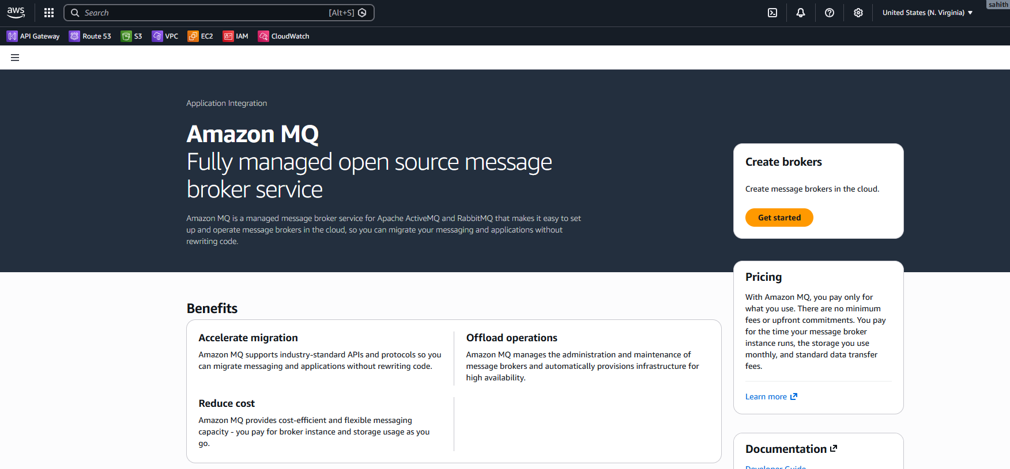
- Selected RabbitMQ as the broker engine.
- Clicked Next.
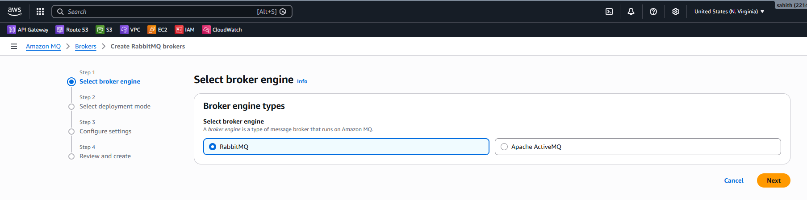
- Selected Single-instance broker as the deployment mode.
- Proceeded to the next step.

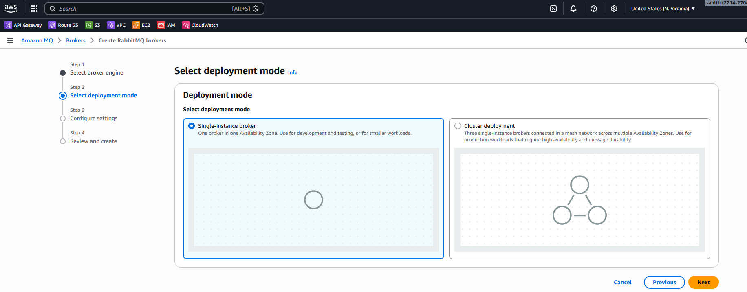
- Entered the Broker name as Taskmq.
- Selected Broker instance type as mq.m7g.medium.
- Confirmed Deployment mode as Single-instance broker.
- Verified Storage type as Amazon Elastic Block Store (EBS).
- Confirmed Broker engine as RabbitMQ.
- Configured RabbitMQ access:
- Entered Username as krishna.
- Entered and confirmed the password.
- Left Additional access methods disabled.
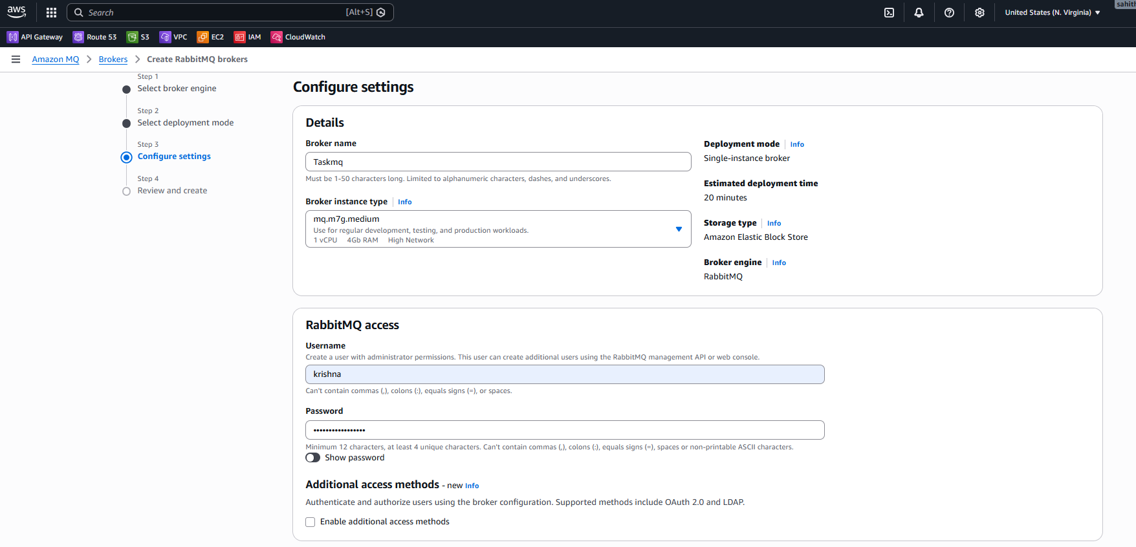
- Skipped Additional settings.
- Did not add any Tags.
- Clicked Next.

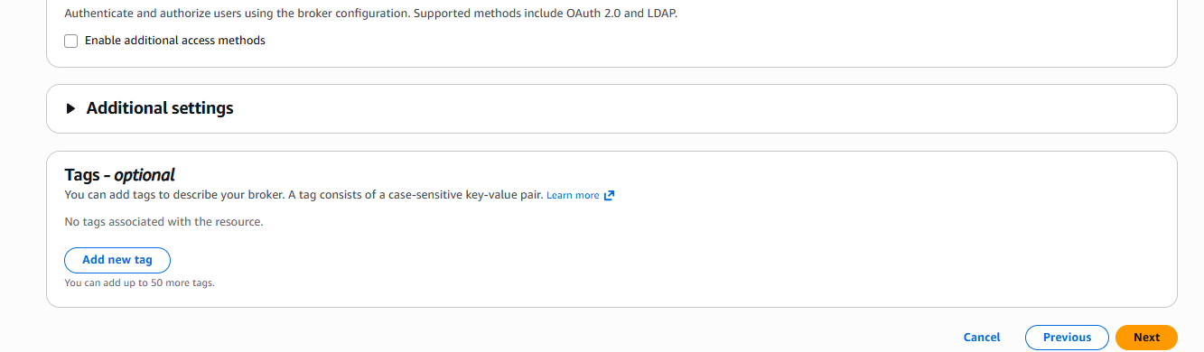
- Reviewed the broker configuration.
- Clicked Create brokers.
- Verified the broker creation status.
- Observed the broker Taskmq in Creation in progress state.
- Confirmed broker details:
  - Region: us-east-1
  - Broker engine: RabbitMQ
  - Deployment mode: Single-instance broker
  - Instance type: mq.m7g.medium
- Amazon MQ has been created successfully and running.
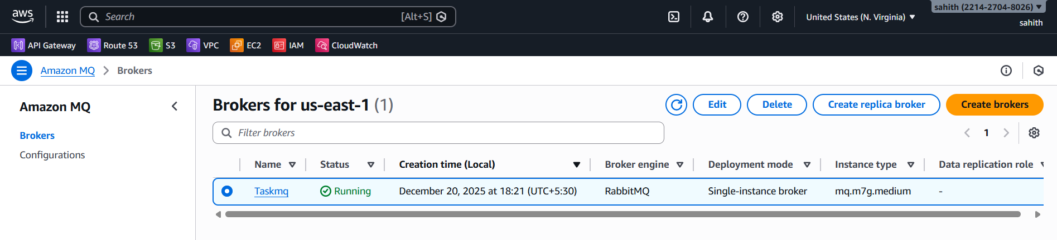
Steps Performed (Amazon MQ – RabbitMQ Console Access)
- Opened AWS Management Console.
- Navigated to Amazon MQ → Brokers.
- Selected the broker named Taskmq.
- Viewed broker Details and confirmed:
  - Broker status is Running.
  - Broker engine is RabbitMQ.
  - Deployment mode is Single-instance broker.
  - Broker instance type is mq.m7g.medium.
  - Public accessibility is Enabled.
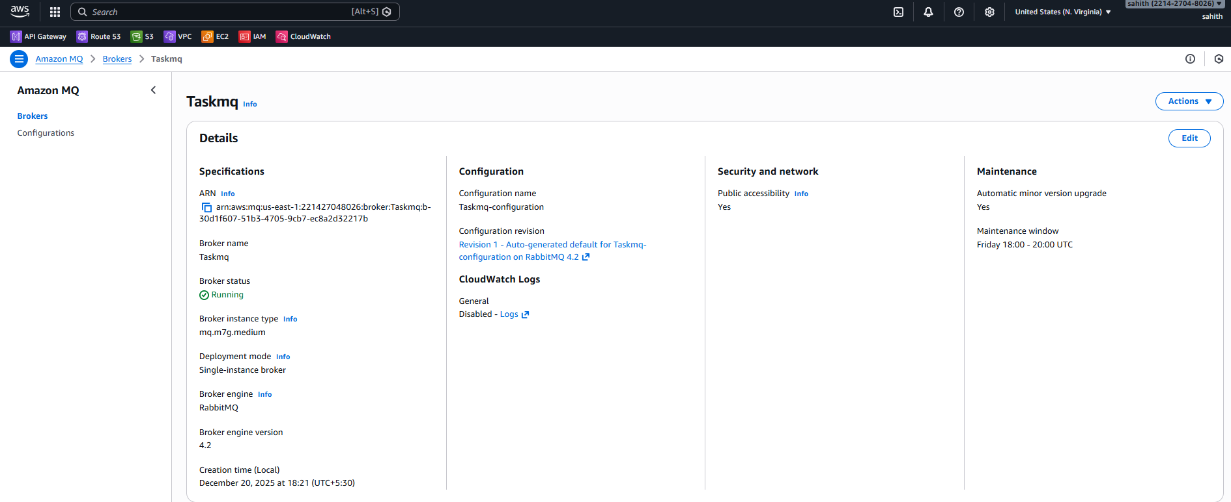
- Scrolled to the Connections section.
- Copied the RabbitMQ web console URL.
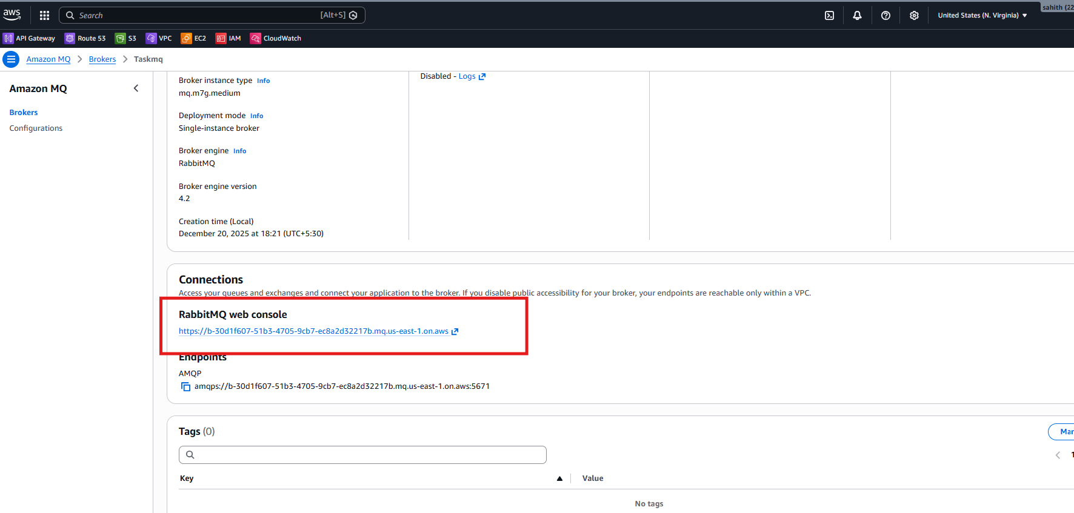
- Opened the RabbitMQ web console URL in a browser.
- Entered the Username as krishna.
- Entered the configured Password.
- Clicked Login.
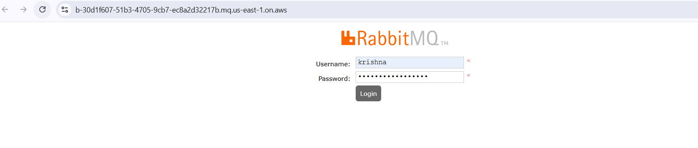
- Successfully logged in to the RabbitMQ Management Console.
- Viewed the Overview dashboard.
- Verified broker information including:
- RabbitMQ version
- Erlang version
- Node status
- Connections, channels, exchanges, queues, and consumers statistics
- Confirmed the broker is running and accessible.
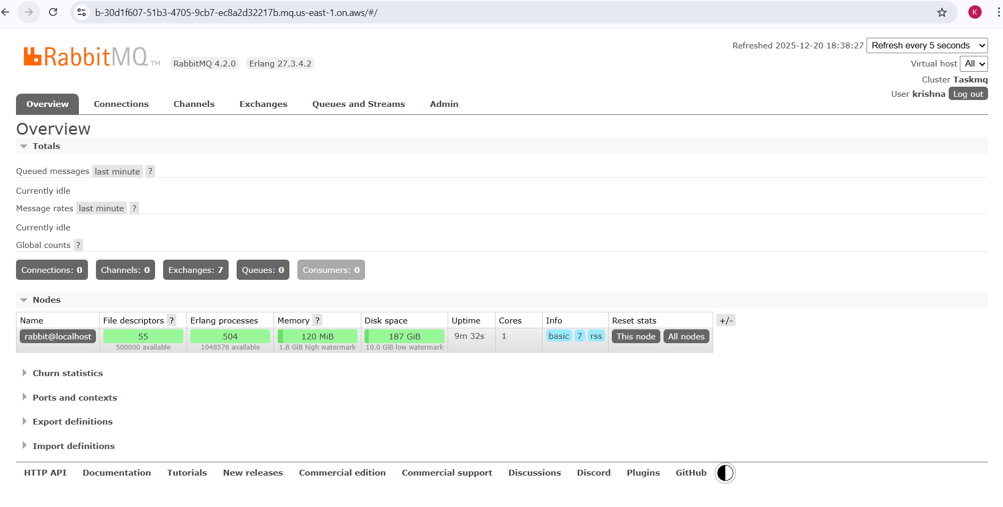
Validation steps:
- Amazon MQ broker Taskmq is created successfully and shows Running status.
- Broker engine is confirmed as RabbitMQ with a single-instance deployment.
- RabbitMQ web console URL is accessible from the browser.
- Successful login to the RabbitMQ management console using configured credentials.
- RabbitMQ dashboard displays broker metrics such as:
  - Connections
  - Channels
  - Exchanges
  - Queues
  - Node health and resource usage
Conclusion:
Amazon MQ RabbitMQ broker was successfully created and validated. Access to the RabbitMQ web management console confirms that the broker is running, publicly accessible, and ready to handle messaging workloads. This setup provides a managed, reliable message broker solution without the need to manually manage underlying infrastructure.

Overall Task Conclusion:
The tasks successfully demonstrates the implementation of AWS messaging services using both Amazon SQS and Amazon MQ. Amazon SQS provides a simple, scalable, and fully serverless queuing mechanism, while Amazon MQ offers a managed RabbitMQ broker for applications requiring traditional messaging protocols and advanced routing. Together, these services enable flexible messaging architectures and support a wide range of application integration and communication patterns on AWS.

